Real-Time Handwritten Digit Recognition Tool

Divija Kalluri
Master’s in computer science
College of Natural Science and Mathematics
Houston, TX, USA
dkalluri@cougarnet.uh.edu
Narasimha Royal Pola
Master’s in computer science
College of Natural Science and Mathematics
Houston, TX, USA
npola@cougarnet.uh.edu

Abstract—This report outlines the development and deployment of a real-time handwritten digit recognition tool using cloud infrastructure powered by AWS SageMaker. The solution incorporates a Convolutional Neural Network (CNN) trained on the MNIST dataset to classify handwritten digits accurately. The project showcases the significant advantages of leveraging cloud computing to simplify machine learning workflows—from data preprocessing to real-time inference through an interactive web application. The proposed approach demonstrates how cloud-based machine learning can be both scalable and efficient, aiming to enhance educational tools that facilitate learning and interaction in practical ways.
Keywords—AWS SageMaker, Convolutional Neural Network, MNIST, Streamlit, Cloud Computing.

Introduction
Handwritten digit recognition is a widely studied problem in computer vision, commonly used to demonstrate the potential of machine learning models. This project aims to create a real-time handwritten digit recognition tool by leveraging the power of cloud computing, specifically AWS SageMaker, to streamline the workflow. Handwritten digit recognition has broad applications, including postal mail sorting, bank check processing, and more recently interactive learning tools. By employing a Convolutional Neural Network (CNN) trained on the MNIST dataset, we aim to achieve accurate and fast classification of handwritten digits. The use of AWS infrastructure not only provides scalability but also reduces the computational burden on local resources, making it accessible and efficient for real-time educational purposes.

Background and Related Work

The MNIST dataset, originally created by Yann LeCun and his colleagues, is one of the most widely used datasets for handwritten digit recognition. It includes 60,000 images for training and 10,000 images for testing, featuring digits from 0 to 9. Each image is a grayscale representation with a resolution of 28x28 pixels. Due to its simplicity, this dataset is a great starting point for testing different machine learning models, particularly convolutional neural networks (CNNs). CNNs excel in visual pattern recognition tasks because of their ability to autonomously learn spatial feature hierarchies, making them ideal for tackling digit recognition challenges.
AWS SageMaker is a cloud-based machine learning service that provides an end-to-end platform for building, training, and deploying models. By using AWS SageMaker, machine learning engineers can focus more on the model and less on managing the infrastructure. This project leverages the SageMaker platform for all stages of model development, including training, hyperparameter tuning, and real-time inference deployment. Streamlit is used to build a simple and intuitive web interface, allowing users to interact with the model by uploading images of handwritten digits and getting instant predictions.

System Architecture

The system's architecture is composed of multiple components that collaborate to offer smoother user experience. The workflow begins with data preprocessing, followed by model deployment, and concludes with user engagement through an interactive web application.

AWS SageMaker Environment Setup

The first step was configuring the AWS SageMaker environment. IAM roles were established to grant the appropriate access permissions, ensuring that all SageMaker components could interact securely. The MNIST dataset was then uploaded to Amazon S3, which served as the project's primary data source.
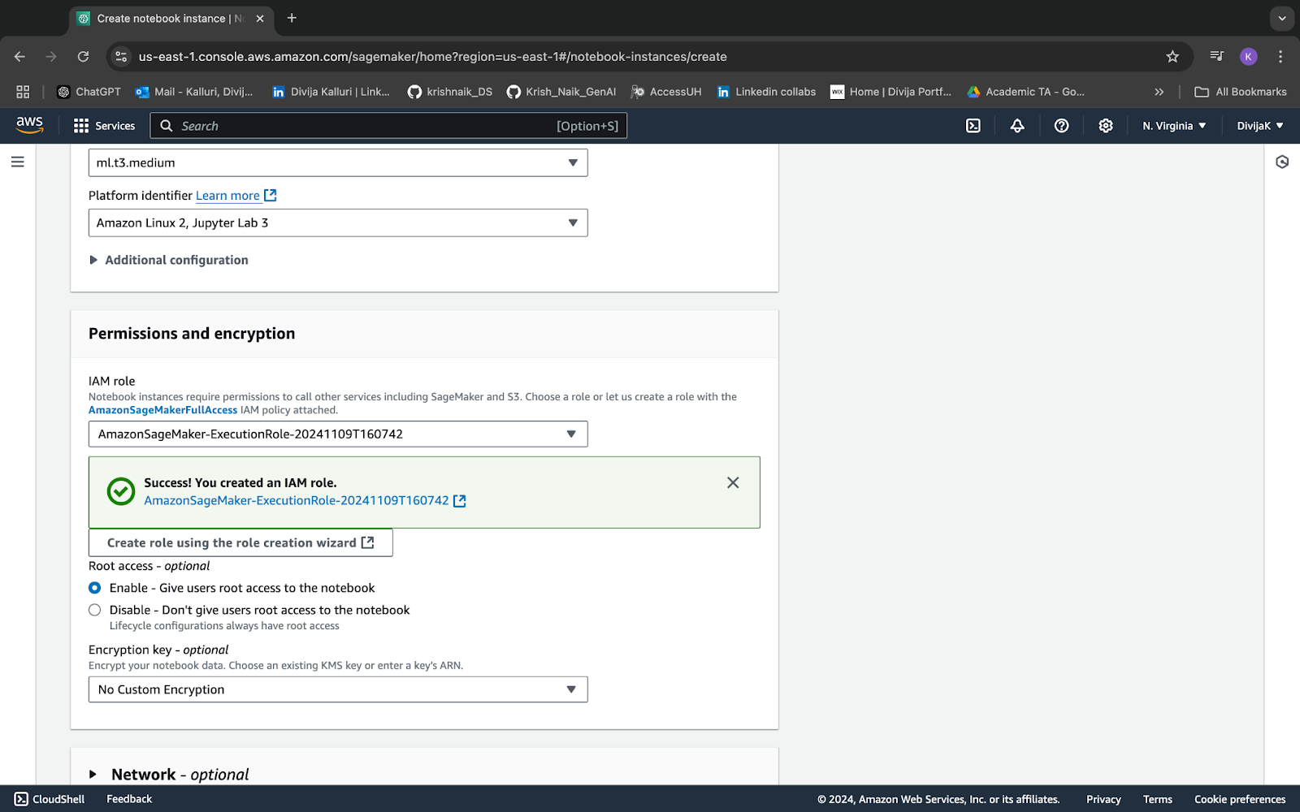
Fig: Setting up IAM role

Data Preprocessing

Data preparation was conducted using SageMaker Data Wrangler, which streamlines tasks like cleaning, transformation, and visualization. The MNIST dataset was normalized so that pixel values ranged between 0 and 1, helping the neural network process the images more efficiently.

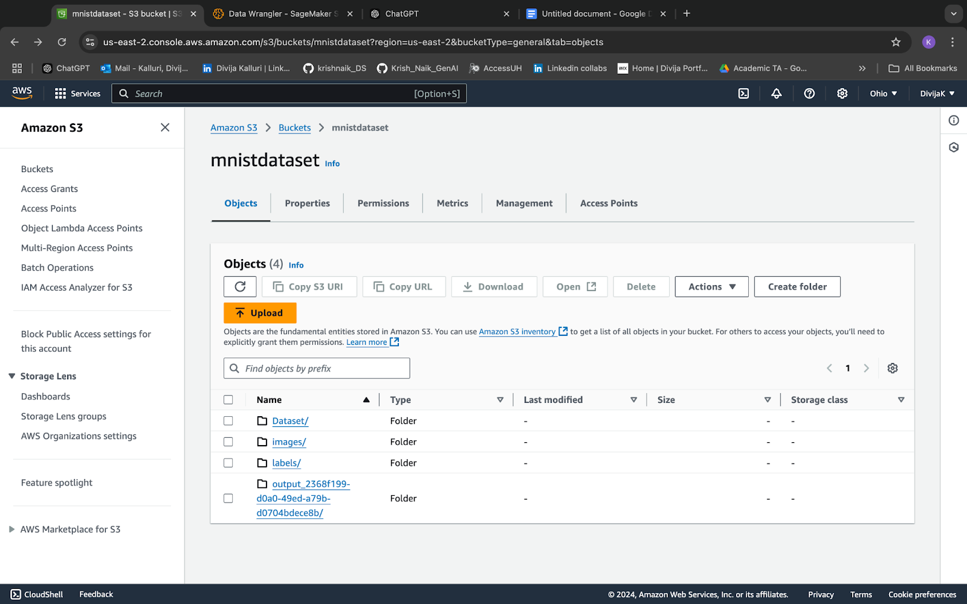

Fig: Loading the data into the S3 bucket

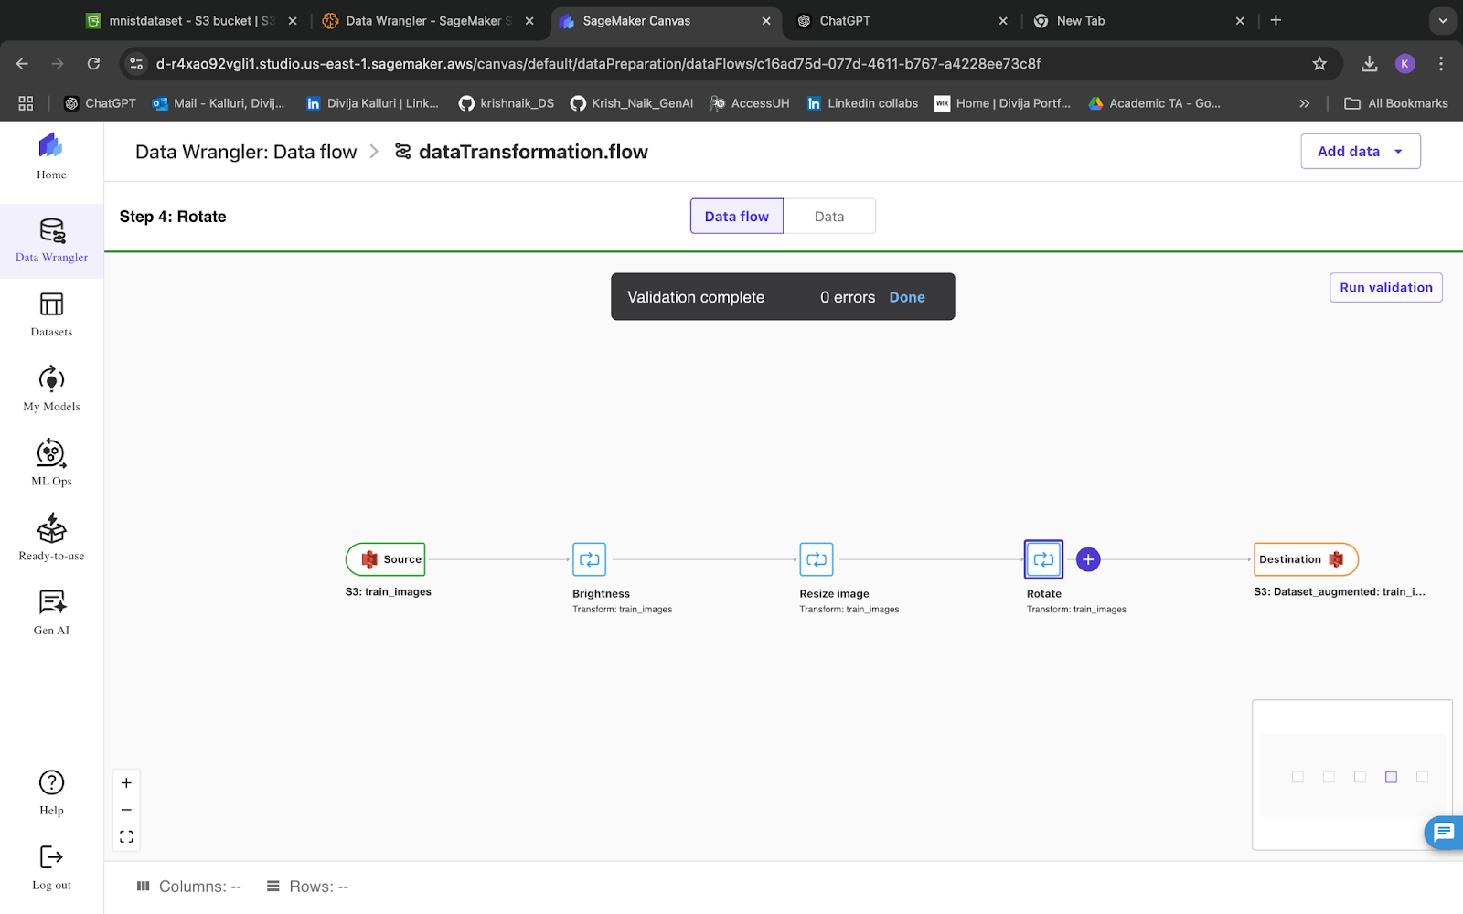
Fig: Data Wrangler

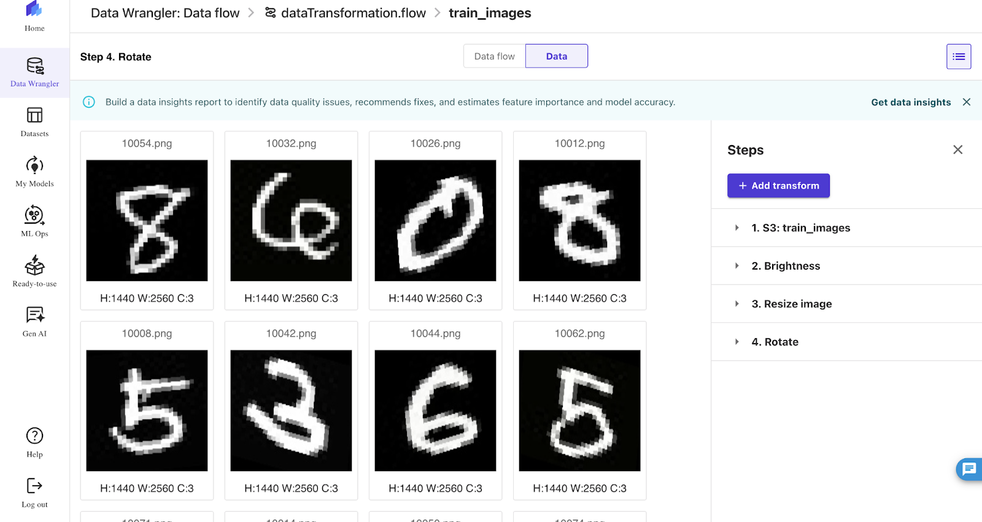
Fig: After Preprocessing

Model Training
A Convolutional Neural Network (CNN) was developed for classifying handwritten digits. The model training was carried out on AWS SageMaker using GPU instances to accelerate the process. Hyperparameter tuning was performed with SageMaker’s integrated tools, optimizing parameters like learning rate, batch size, and the number of epochs to improve the model’s accuracy.

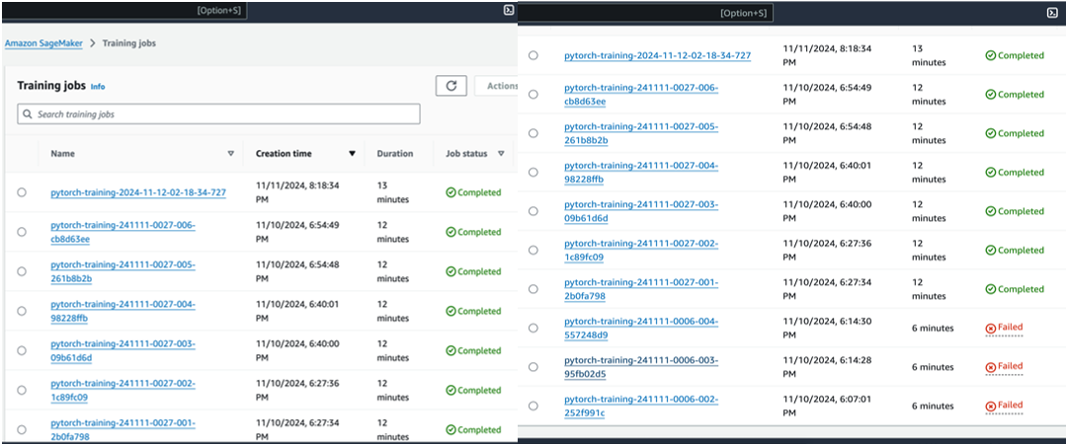

Fig: Training Jobs

Model Deployment
After training and evaluating the model, it was deployed as an endpoint through AWS SageMaker. This endpoint functions as a REST API, accepting input images and providing real-time predictions. The deployed model endpoint is designed to be scalable, efficiently managing multiple requests at once.

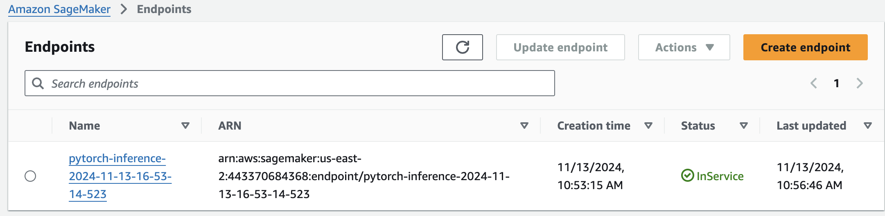

Fig: Deploying End point

Web Application
A web application was created using Streamlit, allowing users to easily upload images of handwritten digits for classification. These images are sent to the deployed model, and the classification results are displayed through the web interface. This setup provides users with an intuitive and interactive way to explore the machine learning model's capabilities.

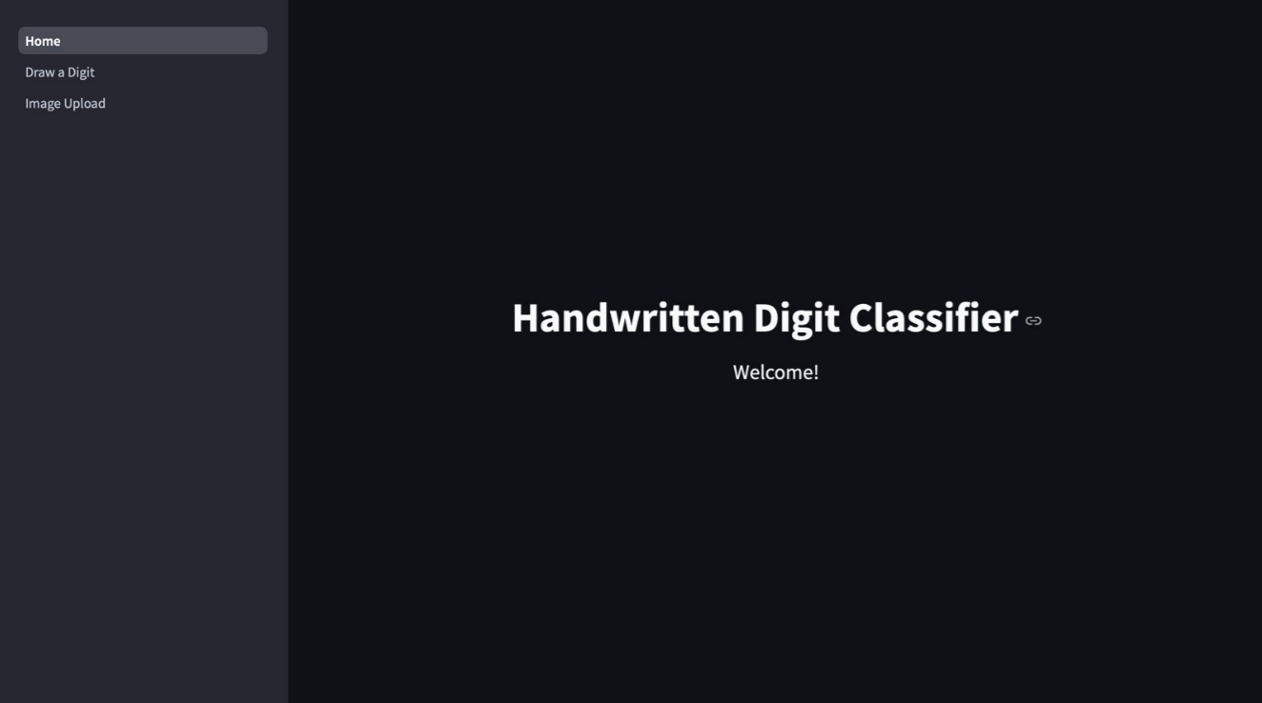
Fig: Interface

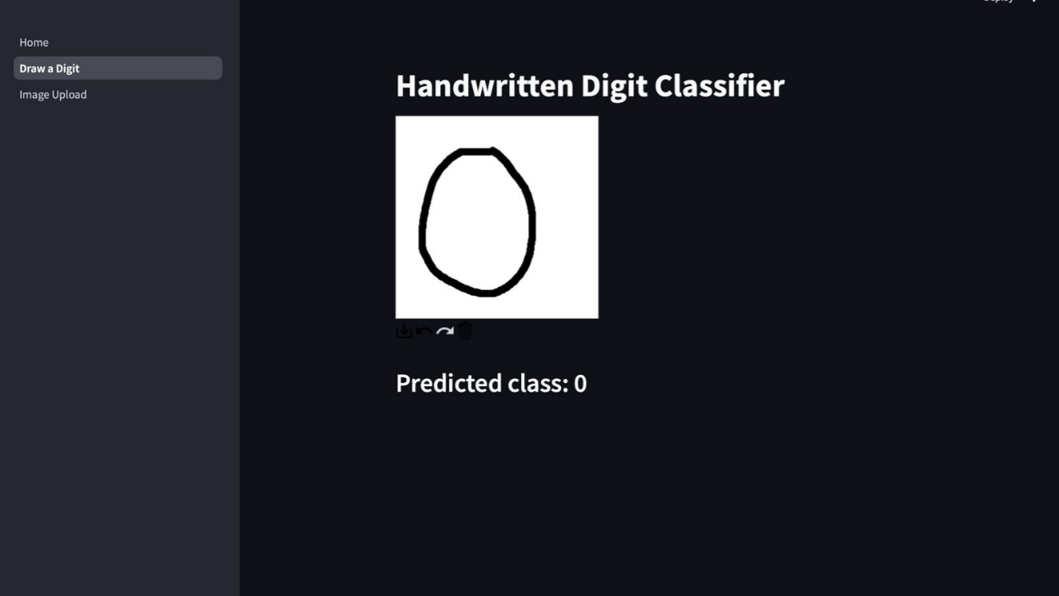
Fig: Prediction-1
The interface enables users to draw a digit in real time using an integrated canvas, receiving an immediate prediction of the digit's class. This real-time interaction offers a smooth and engaging experience, allowing users to easily explore the capabilities of machine learning.

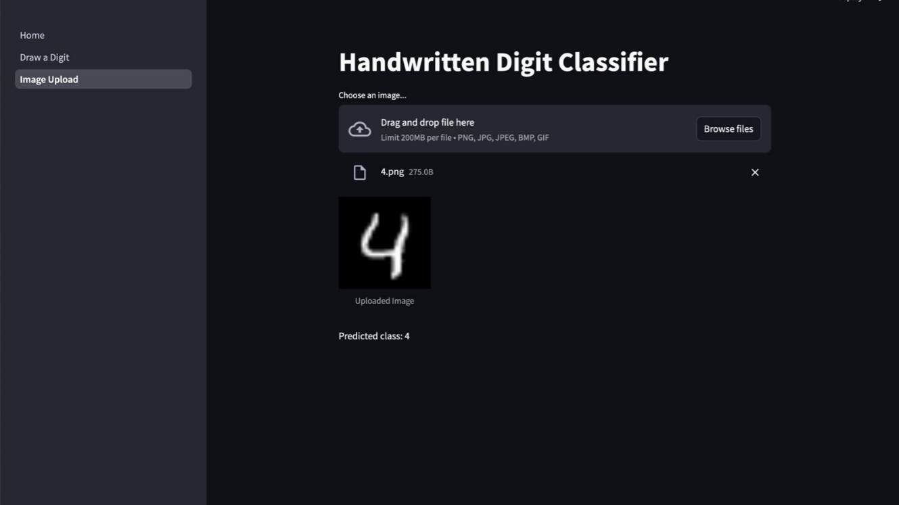
Fig: Prediction-2
The interface also allows users to upload an image of a handwritten digit, including those from the MNIST dataset. Users can either drag and drop an image or browse to select a file for uploading. After the image is uploaded, it is processed, and the model predicts the digit in real time. In the example provided, the uploaded digit is accurately classified as "4." This feature demonstrates the tool's flexibility in managing both live-drawn and pre-existing handwritten digit inputs, offering a well-rounded user experience.

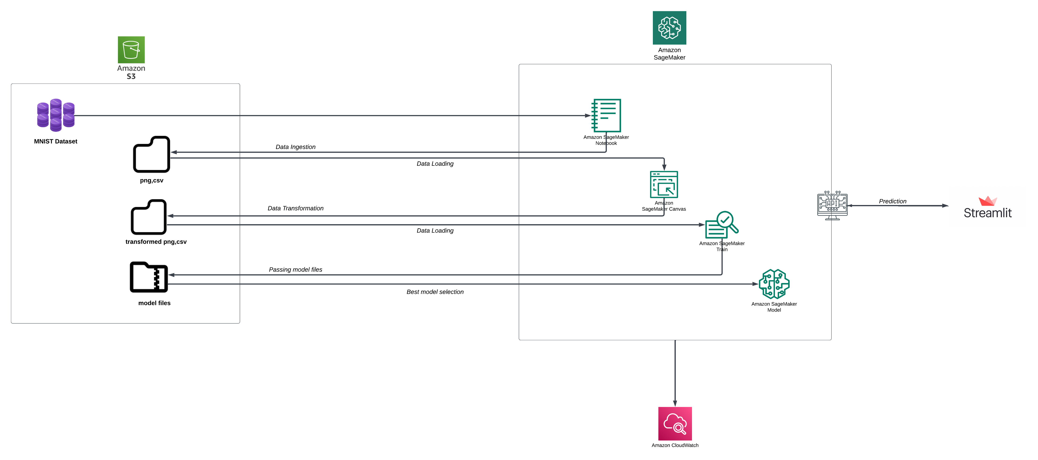
Fig: Architecture

Challenges and Solutions
During the development of the project, several challenges were encountered, each requiring a unique approach to solve.

PyTorch Version Dependencies

One of the early challenges in developing the handwritten digit recognition tool was managing PyTorch version dependencies in the SageMaker environment. AWS SageMaker notebook instances come pre-configured with only certain supported versions of PyTorch for training and deployment, which led to compatibility issues. Specifically, integrating features available in newer or different PyTorch versions that weren't included in the SageMaker default setup proved challenging. Such compatibility issues can complicate the deployment process and create discrepancies between model performance locally and in the cloud.
Solution:
To resolve this issue, we set up a custom environment within SageMaker. By utilizing Docker containers, we crafted an environment tailored to match the specific PyTorch version needed for our project. This approach allowed us to use the latest version of PyTorch, granting access to all necessary features without being limited by SageMaker's default configurations. Additionally, we maintained a comprehensive record of dependencies to ensure consistent reproducibility for both the training and deployment phases.

Discrepancy in Training Time Between Local and Cloud Environment
Another significant challenge encountered was the difference in training times between the local setup and the SageMaker environment. Training on an m4.xlarge instance in AWS SageMaker took around 13 minutes, while the same training process on a local machine required only 5 minutes. This discrepancy was primarily due to differences in hardware specifications and the latency involved with cloud infrastructure. The longer training duration could result in higher costs, particularly when performing multiple rounds of training and hyperparameter tuning.

Solution:

To reduce costs and enhance efficiency, we decided to use Amazon EC2 spot instances. Spot instances offer considerable cost savings by making use of AWS's spare capacity. By strategically utilizing spot instances for less critical training jobs, we successfully reduced overall training expenses by nearly 70%, while still maintaining adequate computational resources. Additionally, we leveraged SageMaker’s managed spot training feature, which automatically manages interruptions associated with spot instances, allowing our training tasks to resume smoothly without needing much manual intervention.

Results and Evaluation

The Convolutional Neural Network (CNN) achieved a test accuracy of 98.79% on the MNIST dataset, reflecting its strong ability to recognize handwritten digits. The model was trained over ten epochs, during which the loss consistently decreased, eventually reaching a final value of 0.0154. This steady decline in loss signifies the model's capacity to learn and improve its identification of patterns in the input images. Hyperparameter tuning was instrumental in this process, as it helped optimize key parameters like learning rate and batch size, ultimately contributing to the high accuracy achieved by the model.

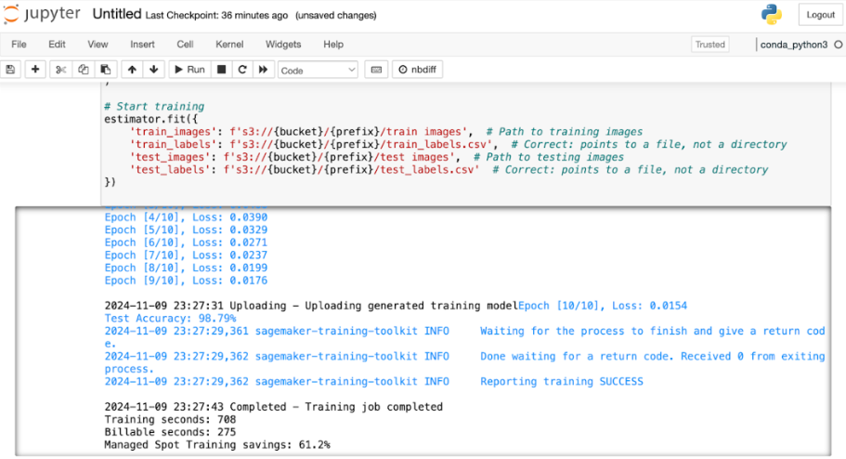
Fig: Test Accuracy

To assess the model's practical use, a real-time inference system was implemented using an endpoint on AWS SageMaker. During deployment testing, the model demonstrated an average response time of under 200 milliseconds, enabling almost instant predictions. Such low latency is critical for interactive applications that require real-time feedback, particularly in educational settings, where prompt responses enhance the learning experience.

The classification results were presented through an intuitive web interface, allowing users to easily upload and classify handwritten digits. Additionally, the interface displayed a confidence score alongside the predicted digit, providing transparency in the model's decision-making process and helping users understand the level of certainty in each prediction. The web interface also featured a simple layout with clear instructions, ensuring that users with minimal technical experience could interact effortlessly with the tool. By combining the power of SageMaker for deployment and user-focused web design, the overall system provided a practical and accessible experience for anyone interested in exploring machine learning capabilities.

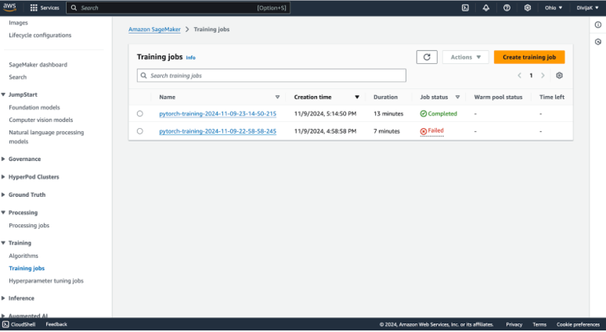
Fig: Training Complete

The training process utilized Amazon EC2 spot instances to minimize expenses while maintaining optimal efficiency. The recorded total training time was 708 seconds, with only 275 seconds being billable, leading to cost savings of 61.2%. This strategy made it possible to use AWS resources effectively without excessive costs, making the solution both financially efficient and scalable. Overall, the model exhibited excellent generalization, high accuracy, and low latency during inference, satisfying the requirements for a real-time handwritten digit recognition system.

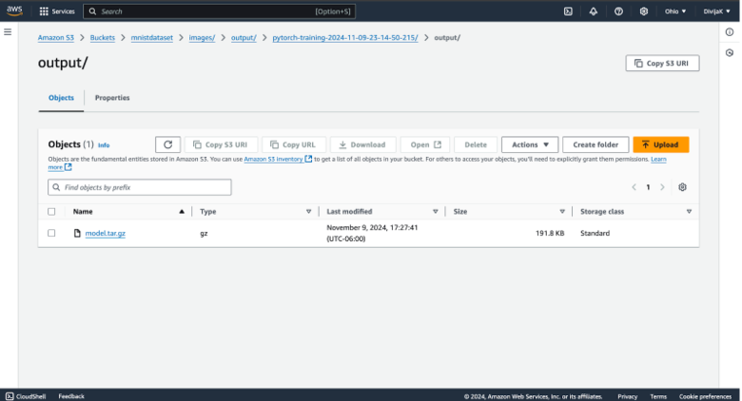
Fig: Output File
The process of hyperparameter tuning was crucial in enhancing model's performance. Essential hyperparameters, including batch size, learning rate, and the number of epochs, were selected strategically to improve model accuracy. The optimal training job resulted in a batch size of 49 and a learning rate of 0.0004114, striking an effective balance between convergence speed and model stability. The tuning objective was defined as "validation accuracy" to ensure that the learning process was adjusted based on the model's performance on validation data, thereby preventing overfitting. The model underwent training for 10 epochs using the PyTorch container on AWS SageMaker, simplifying both the training and deployment phases. These optimized hyperparameters played a major role in achieving a final model accuracy of 98.79%, supporting efficiency while ensuring strong generalization.

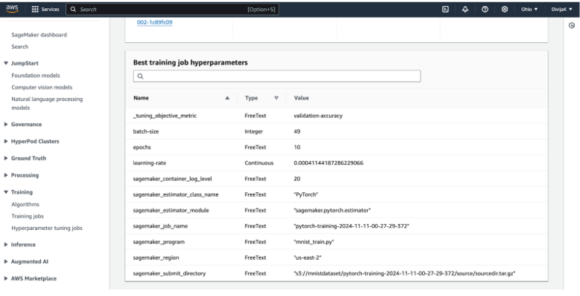
Fig: Best Model

Conclusion
The creation of the real-time handwritten digit recognition tool showcases the strength and versatility of combining machine learning with cloud computing services. Utilizing AWS SageMaker allowed us to address challenges related to infrastructure management, scalability, and cost-effectiveness, enabling us to concentrate on the primary objective: accurately and quickly recognizing handwritten digits. The combination of Convolutional Neural Networks (CNNs) with SageMaker's scalable infrastructure ensured smooth and efficient processes for model training, hyperparameter tuning, and deployment, making the entire workflow both effective and dependable.

The model reached an impressive accuracy of 98.79% on the MNIST dataset, demonstrating the effectiveness of the preprocessing methods, model architecture, and hyperparameter tuning strategy. Leveraging AWS services, such as SageMaker and Amazon S3, helped simplify the complex processes of model training and data management. Additionally, deploying the model as a real-time inference endpoint allowed for the creation of an interactive web application using Streamlit, delivering a user-friendly interface that brings machine learning applications closer to end-users in a practical and accessible way.

In conclusion, this project serves as a demonstration of how cloud-based machine learning solutions can be effectively utilized to solve real-world challenges in a scalable and cost-efficient manner. Integrating machine learning models with cloud platforms like AWS SageMaker offers a transformative approach to developing educational and interactive tools, allowing learners to experience cutting-edge technologies directly. Future enhancements could include broadening the model's capabilities to identify additional handwritten characters or symbols, as well as improving the tool's robustness by incorporating more advanced preprocessing methods. The groundwork established in this project provides significant potential for continued innovation in both educational and practical applications.

References

- LeCun, L. Bottou, Y. Bengio, and P. Haffner, "Gradient-based learning applied to document recognition," Proceedings of the IEEE, 1998. (references)
- AWS Documentation: Amazon SageMaker Developer Guide. Available at: https://docs.aws.amazon.com/sagemaker/
- Streamlit Documentation: Available at: https://docs.streamlit.io/
- I. Goodfellow, Y. Bengio, and A. Courville, "Deep Learning," MIT Press, 2016.

